****BOEM 20xx-xxx

Environmental Studies Program

Report Specifications and Template

Month Year

[insert optional image]

Publication Information

|  |  |
| --- | --- |
| Title |  |
| Publication Date | [month year] |
| Authors |  |
| Agreement or Contract Number |  |
| Prepared by | [organization(s) and address(es)] |
| Published by | U.S. Department of the Interior  Bureau of Ocean Energy Management  City, ST [of the BOEM Office or Region publishing]  Bureau of Ocean Energy Management logo with ocean wave and sun in the letter O  [additional publisher organization(s), location(s), or partner logo(s)]  [contractor logos not permitted] |
| Citation | Lastname FM, Lastname FM, Lastname FM [include up to 10 authors, then use et al.] (Contractor name, City, ST). Year. Report title in sentence caps. City (ST): U.S. Department of the Interior, Bureau of Ocean Energy Management. xx p. Report No.: OCS Study BOEM 20xx-xxx. Contract No.: xxxx.  [Format is CSE 8th Edition.  After title, use the City (ST) of the BOEM region or office.  Number of pages is the total number of pages in the file.] |
| Report Availability | Download a PDF file of this report at https://espis.boem.gov/Final%20Reports/BOEM_20xx-xxx.pdf.  Visit BOEM’s website to [search other studies](https://www.boem.gov/find-environmental-studies) funded by BOEM’s Environmental Studies Program. |
| Disclaimer | [Select and fill out the appropriate disclaimer statement. Remove unused text, bracket marks, and highlighting.]  **[Contracts]** Study concept, oversight, and funding were provided by the U.S. Department of the Interior, Bureau of Ocean Energy Management (BOEM), Environmental Studies Program, Washington, DC, under Contract Number [INSERT NUMBER]. This report has been technically reviewed by BOEM, and it has been approved for publication. The views and conclusions contained in this document are those of the authors and should not be interpreted as representing the opinions or policies of BOEM, nor does mention of trade names or commercial products constitute endorsement or recommendation for use.  **[Interagency and Intra-Agency Agreements]** (select “Interagency” for agreements with Agencies outside of the U.S. Department of the Interior (DOI) or “Intra-Agency” for Agencies within DOI)]  This study was funded, in part, by the U.S. Department of the Interior, Bureau of Ocean Energy Management (BOEM), Environmental Studies Program, Washington, DC, through [Interagency or Intra-Agency] Agreement Number [INSERT NUMBER] with the [INSERT ORGANIZATION]. This report has been technically reviewed by BOEM, and it has been approved for publication. The views and conclusions contained in this document are those of the authors and should not be interpreted as representing the opinions or policies of BOEM, nor does mention of trade names or commercial products constitute endorsement or recommendation for use.  **[Cooperative Agreements]** Study collaboration and funding were provided by the U.S. Department of the Interior, Bureau of Ocean Energy Management (BOEM), Environmental Studies Program, Washington, DC, under Agreement Number [INSERT NUMBER]. This report has been technically reviewed by BOEM, and it has been approved for publication. The views and conclusions contained in this document are those of the authors and should not be interpreted as representing the opinions or policies of BOEM, nor does mention of trade names or commercial products constitute endorsement or recommendation for use. |
| Funding by Fiscal Year |  |
| Cumulative Project Funding |  |
| Keywords |  |
| About the Cover | [optional photo information or credit and/or relevant research permit number] |

List of Contributors

|  |  |
| --- | --- |
| Name / Affiliation | Contribution |
|  | [list in this table any other significant contributors who are not authors] |

Acknowledgments

[Include any recognition of assistance, advice, support, and/or services.]

Technical Summary

Abstract

[Insert text using plain language appropriate for a non-scientific audience]

Background

[text]

Objectives

[text]

Methods

[text]

Results

[text]

Conclusions

[text]

Study Products

[text]

Additional Products Resulting from this Study (peer-reviewed articles, conference presentations, videos, etc.)

[list of published or in press at the time of report submission]

Map of Study Area

[include here if appropriate and if not already shown in the report]

Contents

List of Figures 7

List of Tables 7

List of Abbreviations and Acronyms 8

1 Heading 1 [Style Definitions Guidance] 9

1.1 Heading 2 [Heading Styles Guidance] 9

[1.1.1 Heading 3 (Table Sample and Guidance] 9](#_Toc193347790)

2 References 10

Appendix A: Title 11

# List of Figures

Figure 1. Figure caption in sentence capitalization using the Figure Caption style 10

# List of Tables

Table 1. Sample table title in sentence capitalization using the Table Title style 9

# List of Abbreviations and Acronyms

BOEM Bureau of Ocean Energy Management

# Heading 1 [Style Definitions Guidance]

**Do not modify the style definitions in this template.** Add a new style only if necessary.

This is the Normal style. Font is Arial Nova Condensed, which comes with Windows 10 and higher and is also available for free at Microsoft.com.

## Heading 2 [Heading Styles Guidance]

Heading styles in this template are all followed by the Normal style in the next paragraph. Spacing between headings and paragraphs is already set.

Use Headings 1–6 for the main body of the report. Headings 1–3 are listed in the Contents.

### Heading 3 [Table Sample and Guidance]

See a sample table in **Table 1**. Use the Table Title style to automatically include the table title in the List of Tables. Styles are provided for column headers and table cells.

Data/text in all other cells within a column should have the same alignment (for e.g., left, center, right, or decimal).

Table 1. Sample table title in sentence capitalization using the Table Title style

| Table Header | Table Header | Table Header | Table Header | Table Header |
| --- | --- | --- | --- | --- |
| Table Cell (left) | Table Cell (left) | Table Cell (center) | Table Cell (right) | 4.231 |
| Table Cell (left) | Table Cell (left) | Table Cell (center) | Table Cell (right) | 888.56 |
| Table Cell (left) | Table Cell (left) | Table Cell (center) | Table Cell (right) | 0.38 |

Note: Use the Table Notes style for sources or additional info.

#### Heading 4 [Figure Sample and Guidance]

**Figure 1** provides a sample figure. Figure Caption style is automatically included in the List of Figures. Figure Notes style is provided for additional information.

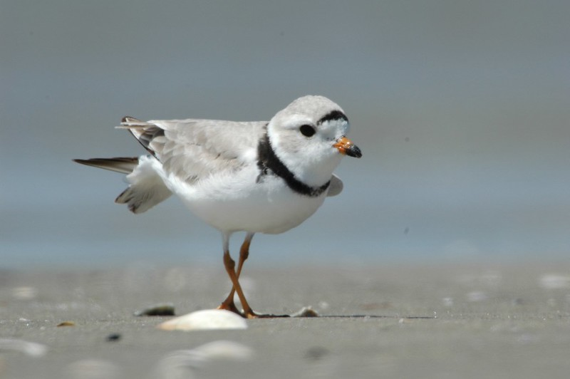

Figure 1. Figure caption in sentence capitalization using the Figure Caption style

Use the Figure Notes style for giving the source or additional info about the figure.

##### Heading 5 [Bulleted List Guidance]

* List Bullet style is default for bulleted lists.
* List Bullet style is default for bulleted lists.
* List Bullet style is default for bulleted lists.

1. Use the Numbered List style for numbered lists.
   1. Use the Numbered List style for numbered lists.
      1. Use the Numbered List style for numbered lists.

# References

[Insert end reference list using the Citation style]

# Appendix A: Title

[Use Heading 1 for appendix headings and use the backspace to delete the section number.]



**U.S. Department of the Interior (DOI)**

DOI protects and manages the Nation's natural resources and cultural heritage; provides scientific and other information about those resources; and honors the Nation’s trust responsibilities or special commitments to American Indians, Alaska Natives, and affiliated island communities.



**Bureau of Ocean Energy Management (BOEM)**

BOEM’s mission is to manage development of U.S. Outer Continental Shelf energy, mineral, and geological resources in an environmentally and economically responsible way.

**BOEM Environmental Studies Program**

The mission of the Environmental Studies Program is to provide the information needed to predict, assess, and manage impacts from offshore energy and marine mineral exploration, development, and production activities on human, marine, and coastal environments. The proposal, selection, research, review, collaboration, production, and dissemination of each of BOEM’s Environmental Studies follows the DOI Code of Scientific and Scholarly Conduct, in support of a culture of scientific and professional integrity, as set out in the   
DOI Departmental Manual (305 DM 3).